When opening the project, make sure that the **Camera Movement** script is implemented into the main camera game object as this is what is needed to move the camera and will allow you to see how the frame rate changes with the help of the **FPS** script that needs to be implements into the **FPS Counter game object**.

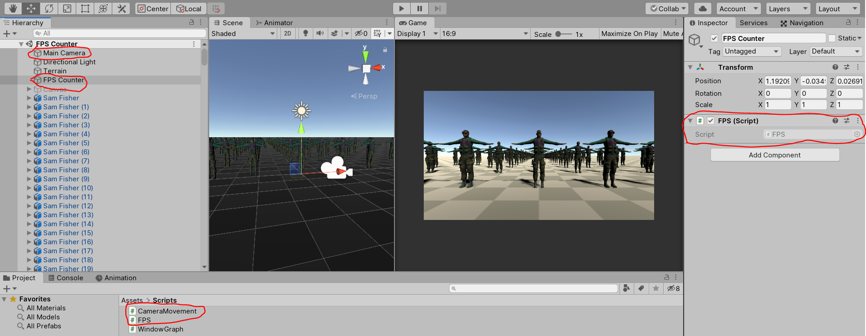

Nothing needs to be added as the rotation speed for the camera and the number display for the FPS counter is already set.

When both scripts have been added in, you should be able to see frame rate appear on the screen. If you want to see the FPS counter change, be sure to add in the 3D models from the prefabs folder and make sure that there are a lot of them as this will interfere with the frame rate, but **do not add too much** as this could make it crash.

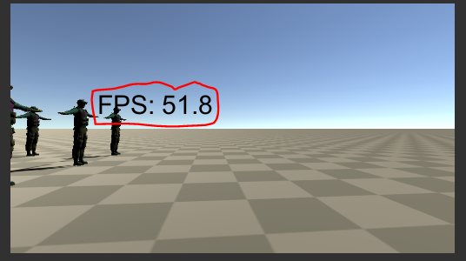

3D models need more processing power than 2D objects, so you will be more likely to see the difference with 3D models.

Ignore the WindowGraph script as this was an attempt at getting a 2D image to work for the frame rate and did not work so well.